**PASSWORD ENCRYPT REQUEST ANGULAR 4**

REF: <https://www.npmjs.com/package/crypto-js>

IN ORDER TO ACHIEVE THIS, WE HAVE TO INSTALL SOME DEPENDECIES ON MIDDLEWARE AND FRONT-END SERVERS

ANGULAR 4:

**NOTICE:** THIS PROCESS HAS BEEN DONE WITH AN ANGULAR-CLI PROJECT ON LOCAL MACHINE OPERATING SYSTEM NOT ON VAGRANTBOX SERVER.

INSTALL ***crypto-js*** *USING NEXT COMMAND:* ***npm install crypto-js -save***

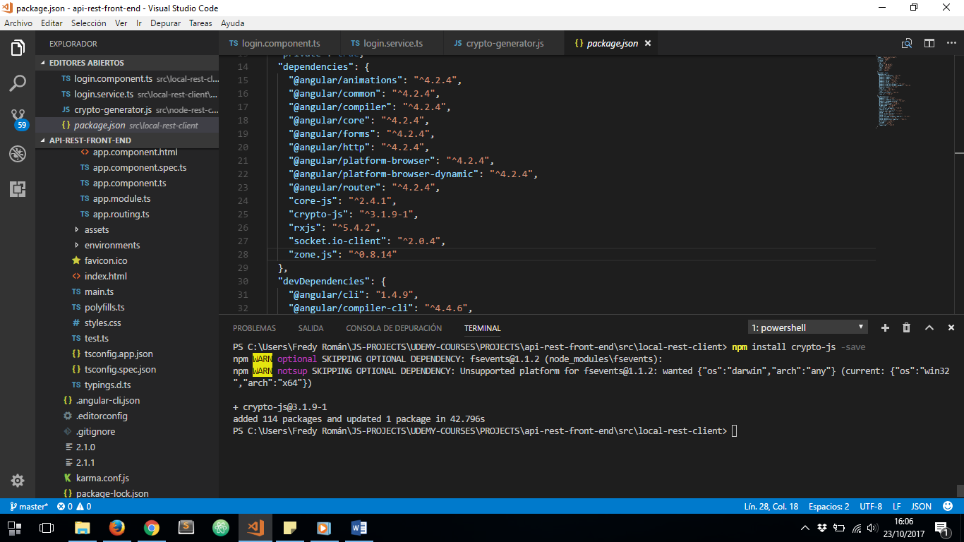

NOW IN ***login.service.ts*** WE HAVE TO DO NEXT:

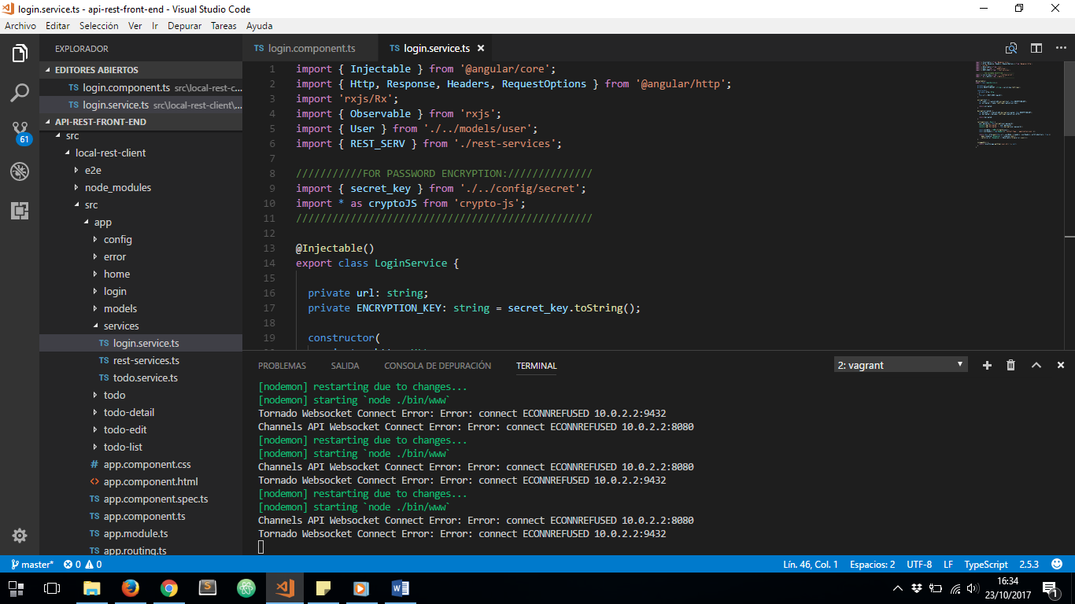

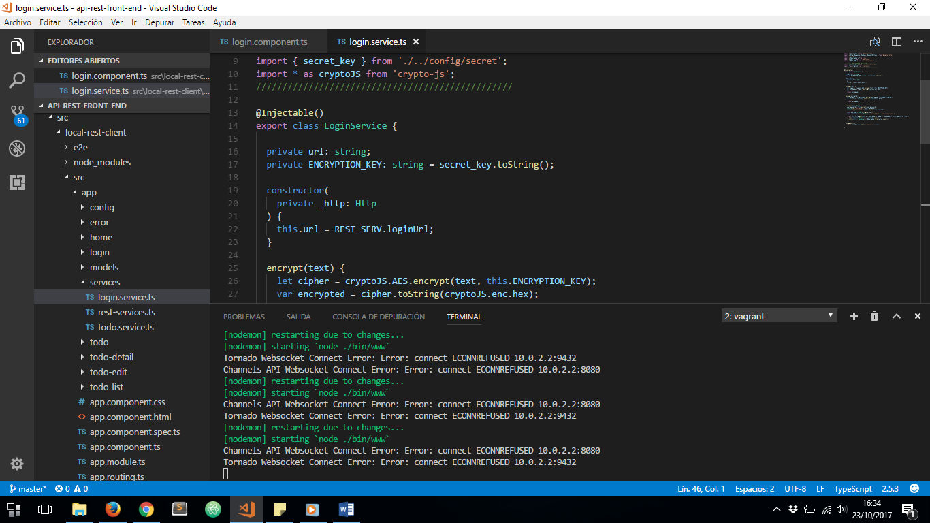

CREATING ENCRYPT AND DECRYPT METHODS AND CALL THEM BEFORE CALL HTTP POST LOGIN METHOD TO MIDDLEWARE SERVER:

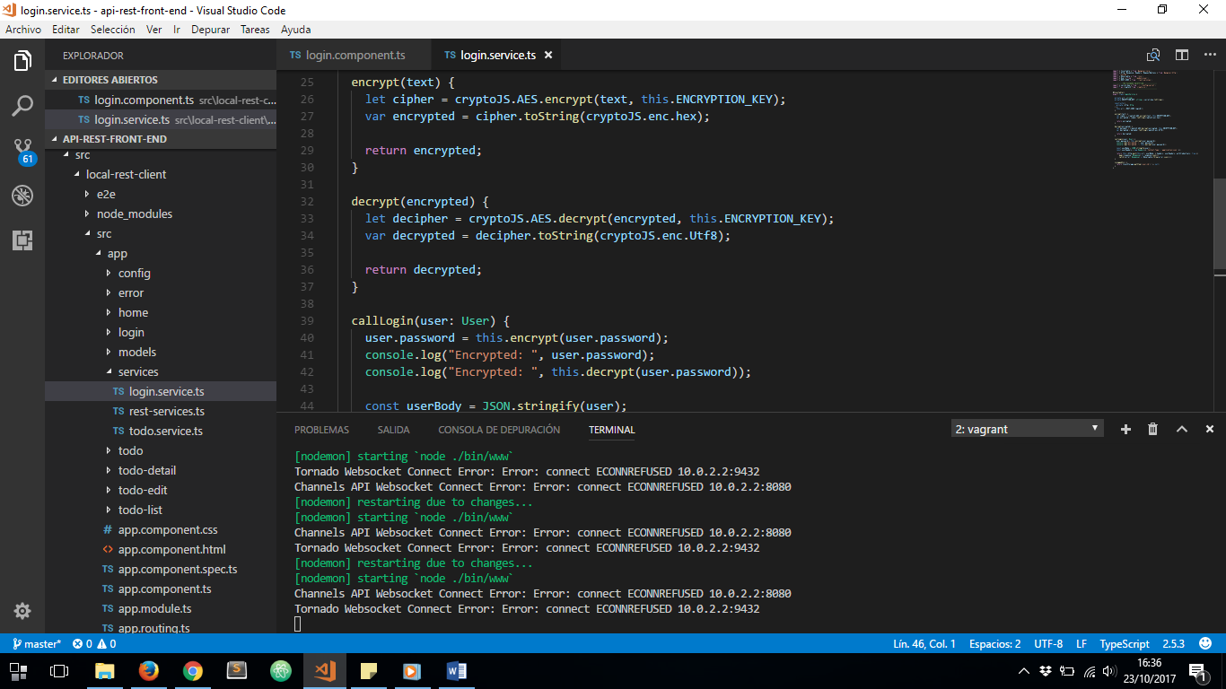

EXPRESS.JS:

**NOTICE:** WE’RE STILL USING VAGRANT BOX TO RUN OUR MIDDLEWARE SERVER.

INSTALL ***crypto-js*** WITH NEXT COMMAND: ***npm install crypto-js –no-bin-links -save***

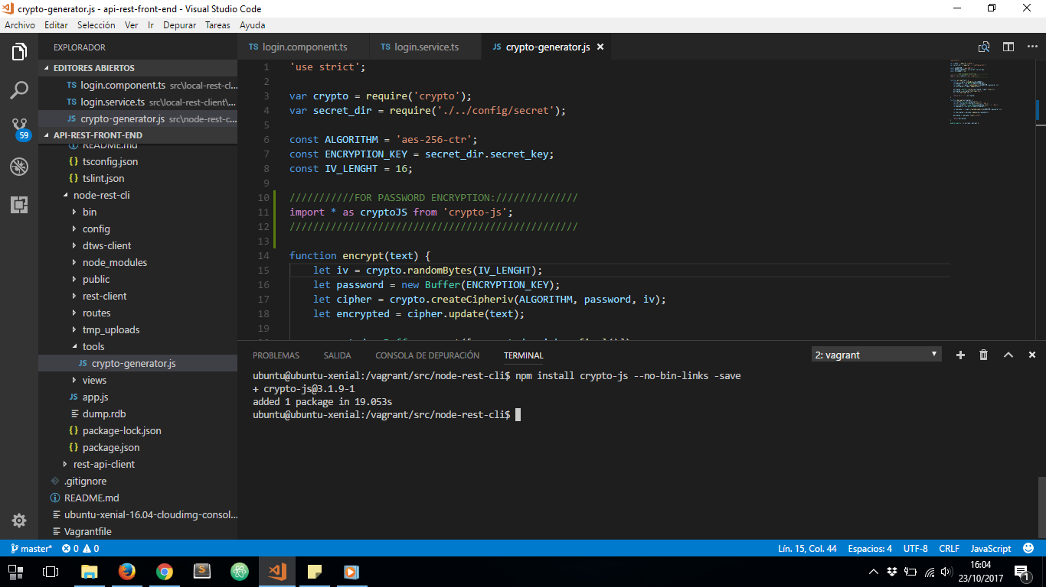

***crypto-generator.js*** FILE:

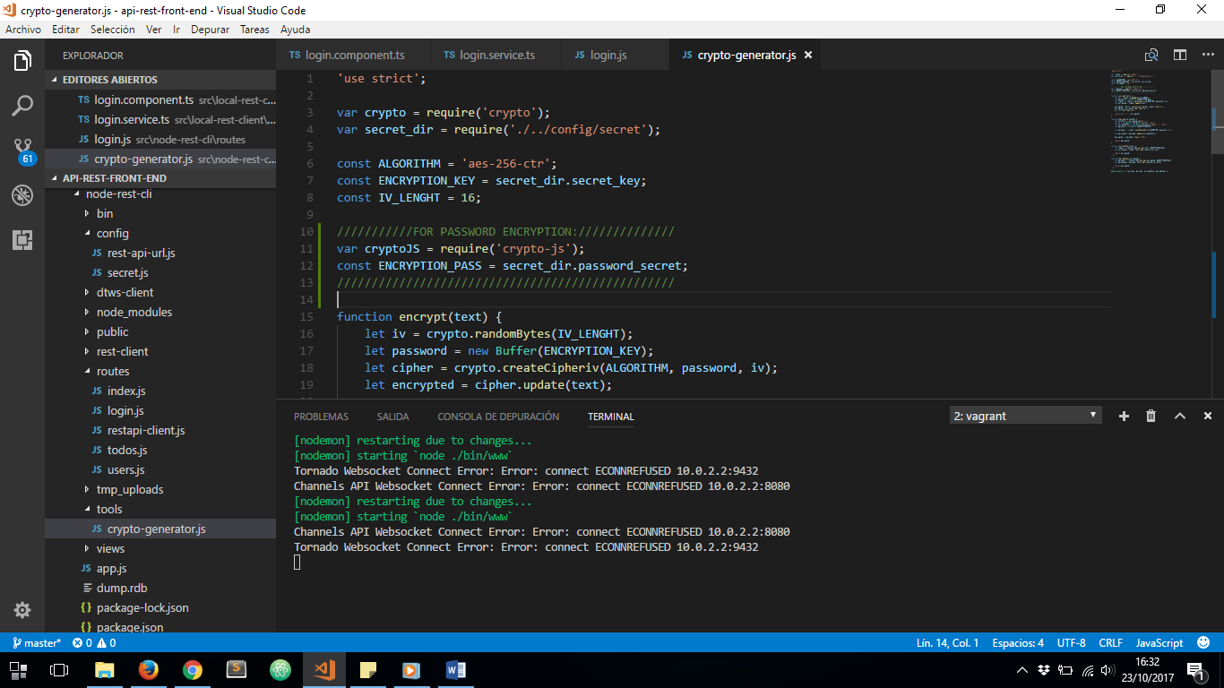

DEFINING ENCRYPT AND DECRYPT FOR USER PASSWORD

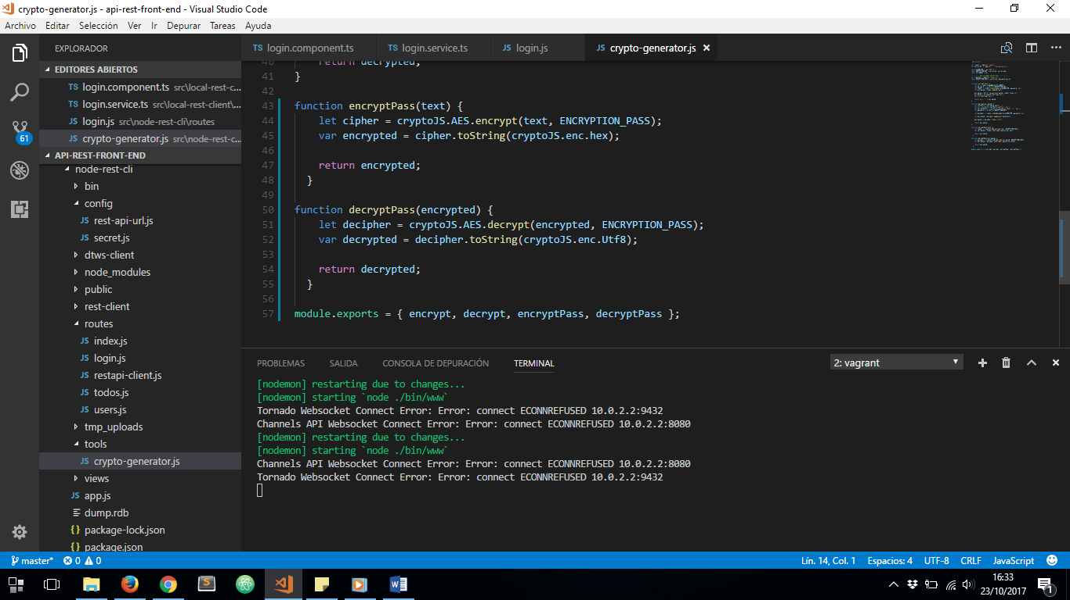

***login.js*** FILE, CALLING DECRYPT PASSWORD METHOD BEFORE SEND CREDENTIALS TO BACKEND SERVER:

